- BQ1
SELECT W_JOB_F.Location_ID,Location_Name, W_SALES_CLASS_D.Sales_class_id, Sales_Class_De sc, Time_Year,Time_Month,Base_price, SUM(Quantity_Ordered) AS SUMQTY, SUM(Quantity_Ordered*Unit_Price) AS Job_Amount

FROM W_JOB_F, W_LOCATION_D, W_SALES_CLASS_D, W_TIME_D

WHERE W_JOB_F.Location_ID = W_LOCATION_D.Location_ID AND W_JOB_F.Sales_class_id = W_SALES_CLASS_D.Sales_class_id AND W_TIME_D.Time_id = W_JOB_F.Contract_date

GROUP BY W_JOB_F.Location_ID, Location_Name,W_SALES_CLASS_D.Sales_class_id, Sales_Class_Desc,Time_Year, Time_Month,Base_price;

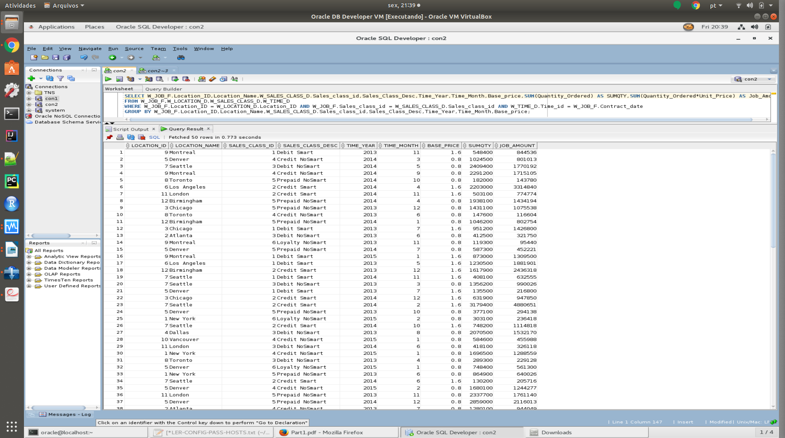

- BQ2
SELECT W_JOB_F.JOB_ID, W_JOB_F.Location_ID, W_Location_D.Location_Name, Unit_Price, Quantity_Ordered, Time_Year, Time_Month, SUM(Invoice_Amount) AS SUMINVAMT, SUM(Invoice_Quantity) AS SUMINVQTY

FROM W_JOB_F, W_LOCATION_D, W_TIME_D, W_INVOICELINE_F, W_SUB_JOB_F, W_JOB_SHIPMENT_F

WHERE W_JOB_F.Location_ID = W_LOCATION_D.Location_ID AND W_TIME_D.Time_id = W_JOB_F.Contract_date AND W_Job_Shipment_F.Invoice_Id = W_InvoiceLine_F.Invoice_Id AND W_JOB_F.Job_Id = W_SUB_JOB_F.Job_Id AND W_JOB_SHIPMENT_F.Sub_Job_Id = W_Sub_Job_F.Sub_Job_Id

GROUP BY W_JOB_F.JOB_ID, W_JOB_F.Location_ID, W_Location_D.Location_Name, Unit_Price, Quantity_Ordered, Time_Year, Time_Month;

CREATE VIEW BQ2 AS
SELECT W_JOB_F.JOB_ID, W_JOB_F.Location_ID, W_Location_D.Location_Name, Unit_Price, Quantity_Ordered, Time_Year, Time_Month, SUM(Invoice_Amount) AS SUMINVAMT, SUM(Invoice_Quantity) AS SUMINVQTY

FROM W_JOB_F, W_LOCATION_D, W_TIME_D, W_INVOICELINE_F, W_SUB_JOB_F, W_JOB_SHIPMENT_F

WHERE W_JOB_F.Location_ID = W_LOCATION_D.Location_ID AND W_TIME_D.Time_id = W_JOB_F.Contract_date AND W_Job_Shipment_F.Invoice_Id = W_InvoiceLine_F.Invoice_Id AND W_JOB_F.Job_Id = W_SUB_JOB_F.Job_Id AND W_JOB_SHIPMENT_F.Sub_Job_Id = W_Sub_Job_F.Sub_Job_Id

GROUP BY W_JOB_F.JOB_ID, W_JOB_F.Location_ID, W_Location_D.Location_Name, Unit_Price, Quantity_Ordered, Time_Year, Time_Month;

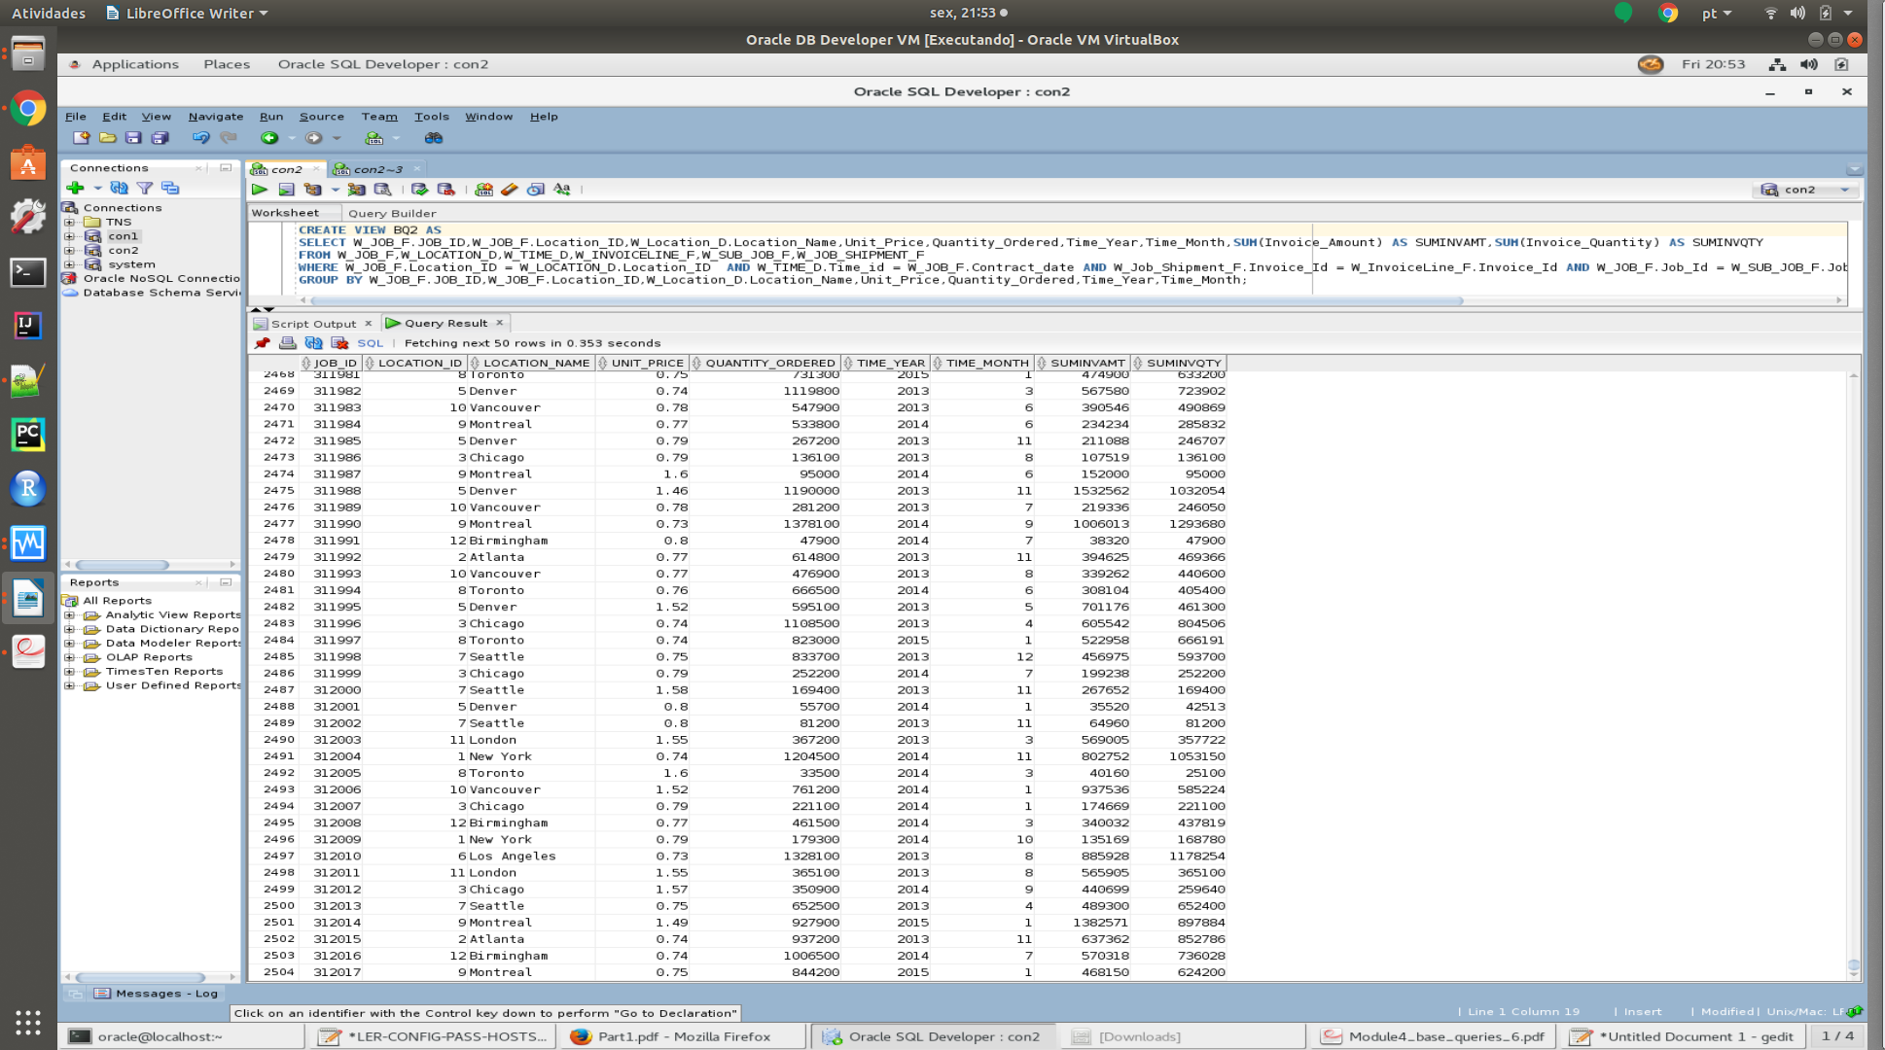

- BQ3
CREATE VIEW BQ3 AS
SELECT JOB_ID, Location_ID, Location_Name, Time_Year, Time_Month, SUMLABOUR,
SUMMATERIAL, SUMOVERHEAD, SUMMACHINE, SUMQTY, TOTALCOST, TOTALCOST/SUMQTY AS UNIT_PRICE

FROM ( SELECT W_SUB_JOB_F.JOB_ID, W_SUB_JOB_F.Location_ID, Location_Name, Time_Year, Time_Mont h, SUM(Cost_Labor) AS SUMLABOUR, SUM(Cost_Material) AS SUMMATERIAL, SUM(Cost_Overhead) AS SUMOVERHEAD, SUM(Machine_Hours*Rate_per_hour) AS SUMMACHINE, SUM(Quantity_produced) AS SUMQTY, SUM(Cost_Labor+Cost_Material+Cost_Overhead+Machine_Hours*Rate_per_hour) AS TOTALCOST

FROM W_SUB_JOB_F, W_JOB_F, W_TIME_D, W_LOCATION_D, W_MACHINE_TYPE_D

WHERE W_SUB_JOB_F.Job_id = W_JOB_F.Job_id AND W_location_d.location_id = W_SUB_JOB_F.Location_id AND W_Time_D.Time_id = W_Job_F.Contract_Date AND W_SUB_JOB_F.Machine_Type_id = W_Machine_Type_D.Machine_Type_ID
GROUP BY W_SUB_JOB_F.JOB_ID, W_SUB_JOB_F.Location_ID, Location_Name, Time_Year, Time_Month);

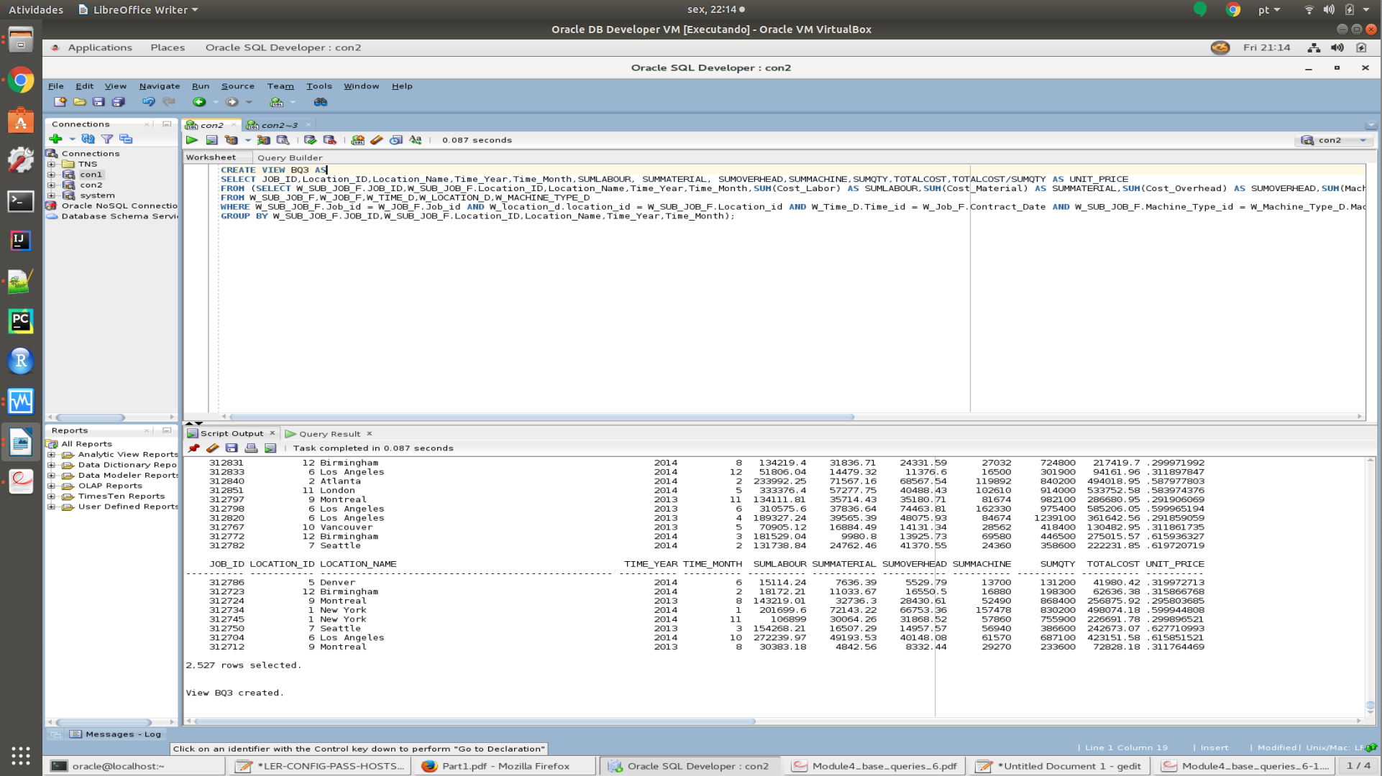

- BQ4
SELECT W_InvoiceLine_F.Location_Id, Location_Name,W_InvoiceLine_F.Sales_Class_Id,
Sales_Class_Desc,Time_Year, Time_Month, SUM ( Quantity_shipped - Invoice_Quantity ) as QTYRETURNED,SUM ( (Quantity_shipped - Invoice_quantity) * (Invoice_amount/Invoice_quantity) ) AS SUMAMTRETURNED

FROM W_INVOICELINE_F,W_Location_D ,W_Sales_Class_D,W_TIME_D

WHERE quantity_shipped - invoice_quantity > 0 AND W_INVOICELINE_F.INVOICE_SENT_DATE = W_TIME_D.TIME_ID AND W_INVOICELINE_F.Location_Id = W_Location_D.Location_Id AND
W_INVOICELINE_F.Sales_Class_Id = W_Sales_Class_D.Sales_Class_Id

GROUP BY W_InvoiceLine_F.Location_Id, Location_Name,W_InvoiceLine_F.Sales_Class_Id, Sales_Class_Desc,Time_Year, Time_Month;
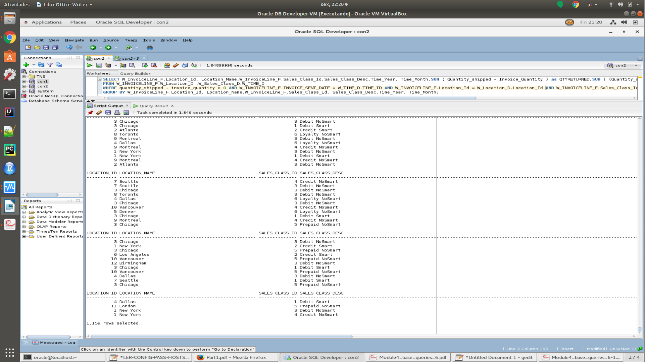

- BQ5
CREATE VIEW BQ5 AS
SELECT Job_id, Location_ID, Location_Name, Sales_class_id, sales_class_desc, Date_Promised, Quantity_Ordered, LastShipDate, SUMSHIPQTY, getBusDaysDiff(LastShipDate, Date_Promised) AS DaysDiff

FROM (SELECT W_JOB_F.Job_id, W_JOB_F.Location_ID, Location_Name, W_JOB_F.Sales_class_id, sales_class_desc, Date_Promised, Quantity_Ordered, MAX(Actual_Ship_Date) AS LastShipDate, SUM(Actual_Quantity) AS SUMSHIPQTY

FROM W_JOB_F, W_LOCATION_D, W_SALES_CLASS_D, W_SUB_JOB_F, W_JOB_SHIPMENT_F

WHERE Actual_Ship_Date > Date_Promised AND W_JOB_F.Location_id = W_LOCATION_D.Location_id AND W_Job_F.Sales_Class_Id = W_Sales_Class_D.Sales_Class_Id AND W_SUB_JOB_F.SUB_JOB_ID = W_JOB_SHIPMENT_F.SUB_JOB_ID AND W_Job_F.Job_Id = W_SUB_JOB_F.JOB_ID

GROUP BY W_JOB_F.Job_id, W_JOB_F.Location_ID, Location_Name, W_JOB_F.Sales_class_id, sales_class_desc, Date_Promised, Quantity_Ordered)

WHERE LastShipDate > Date_Promised;
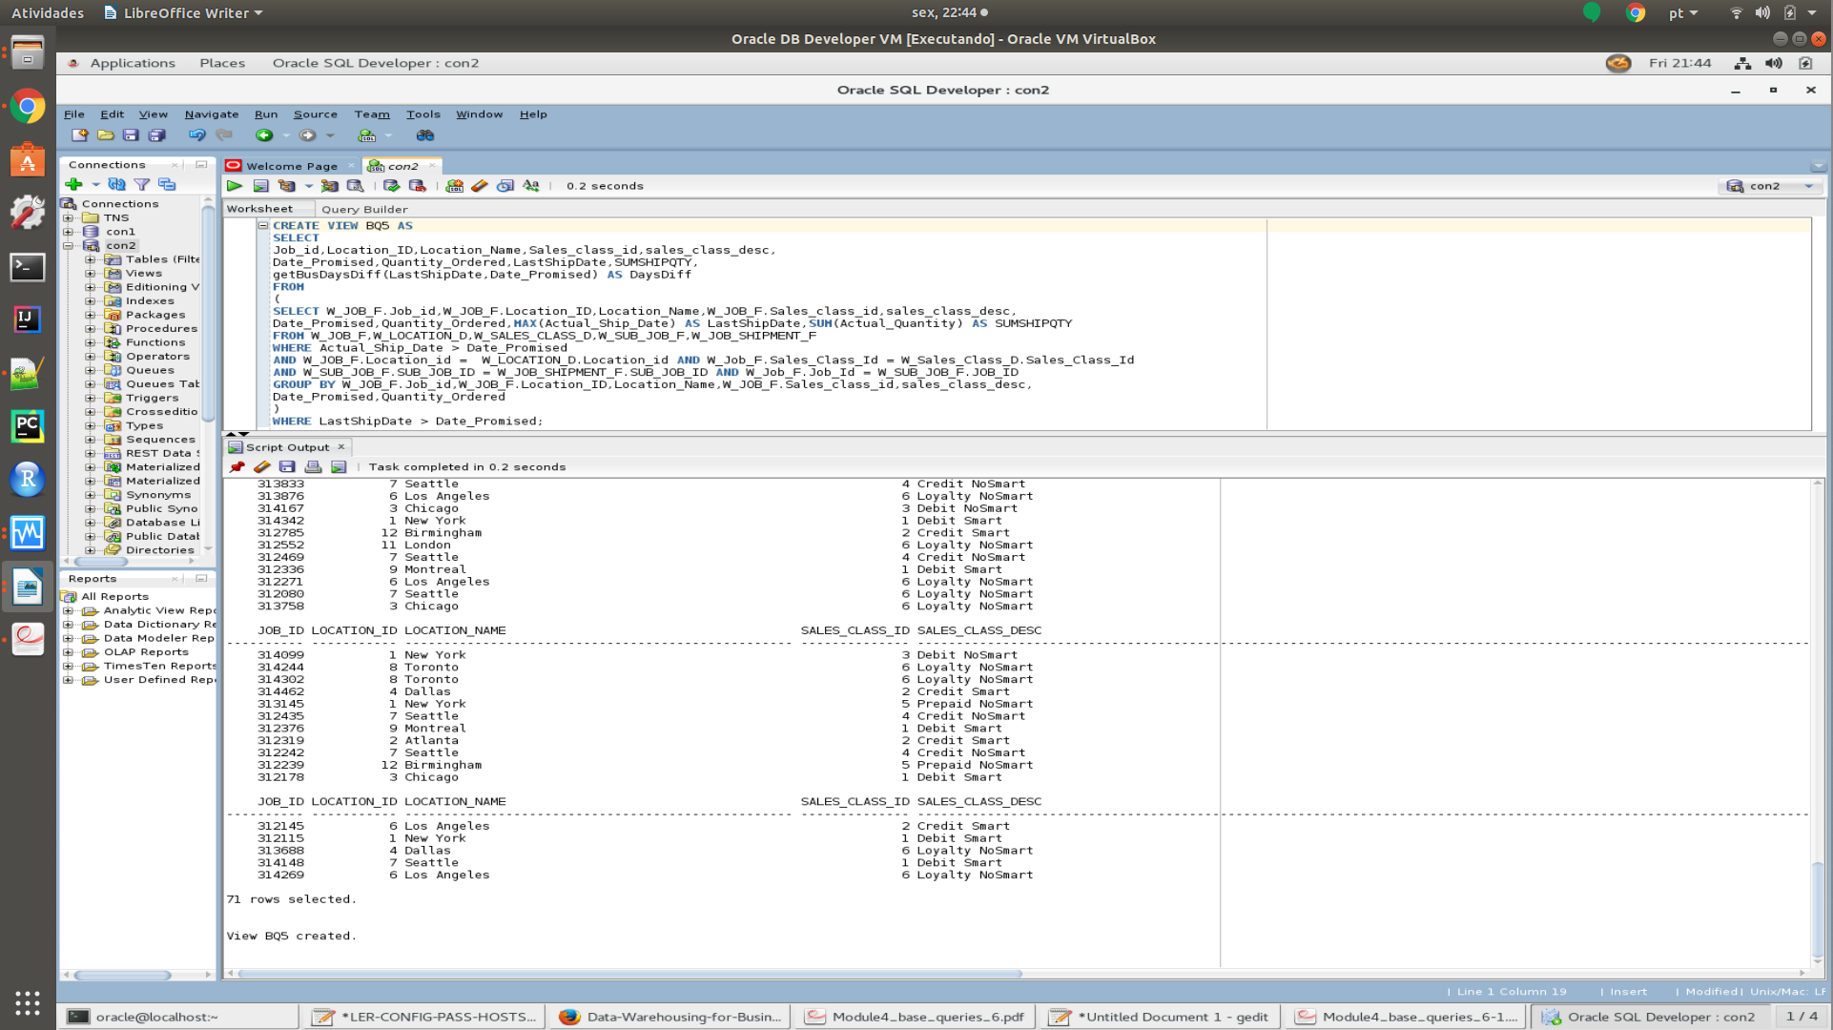

- BQ6
CREATE VIEW BQ6 AS
SELECT Job_id, Location_ID, Location_Name, Sales_class_id, sales_class_desc, Date_Ship_By, FirstShipDate, getBusDaysDiff(FirstShipDate, Date_Ship_By) AS DaysDiff

FROM (SELECT W_JOB_F.Job_id, W_JOB_F.Location_ID, Location_Name, W_JOB_F.Sales_class_id, sales_class_desc, Date_Ship_By, MIN(Actual_Ship_Date) AS FirstShipDate

FROM W_JOB_F, W_LOCATION_D, W_SALES_CLASS_D, W_SUB_JOB_F, W_JOB_SHIPMENT_F

WHERE W_JOB_F.Location_id = W_LOCATION_D.Location_id AND W_Job_F.Sales_Class_Id = W_Sales_Class_D.Sales_Class_Id AND W_SUB_JOB_F.SUB_JOB_ID = W_JOB_SHIPMENT_F.SUB_JOB_ID AND W_Job_F.Job_Id = W_SUB_JOB_F.JOB_ID

GROUP BY W_JOB_F.Job_id, W_JOB_F.Location_ID, Location_Name, W_JOB_F.Sales_class_id, sales_class_desc, Date_Ship_By)

WHERE FirstShipDate > Date_Ship_By;



